**Ein Bild, das Text, Säugetier, Pferd, draußen enthält.
**

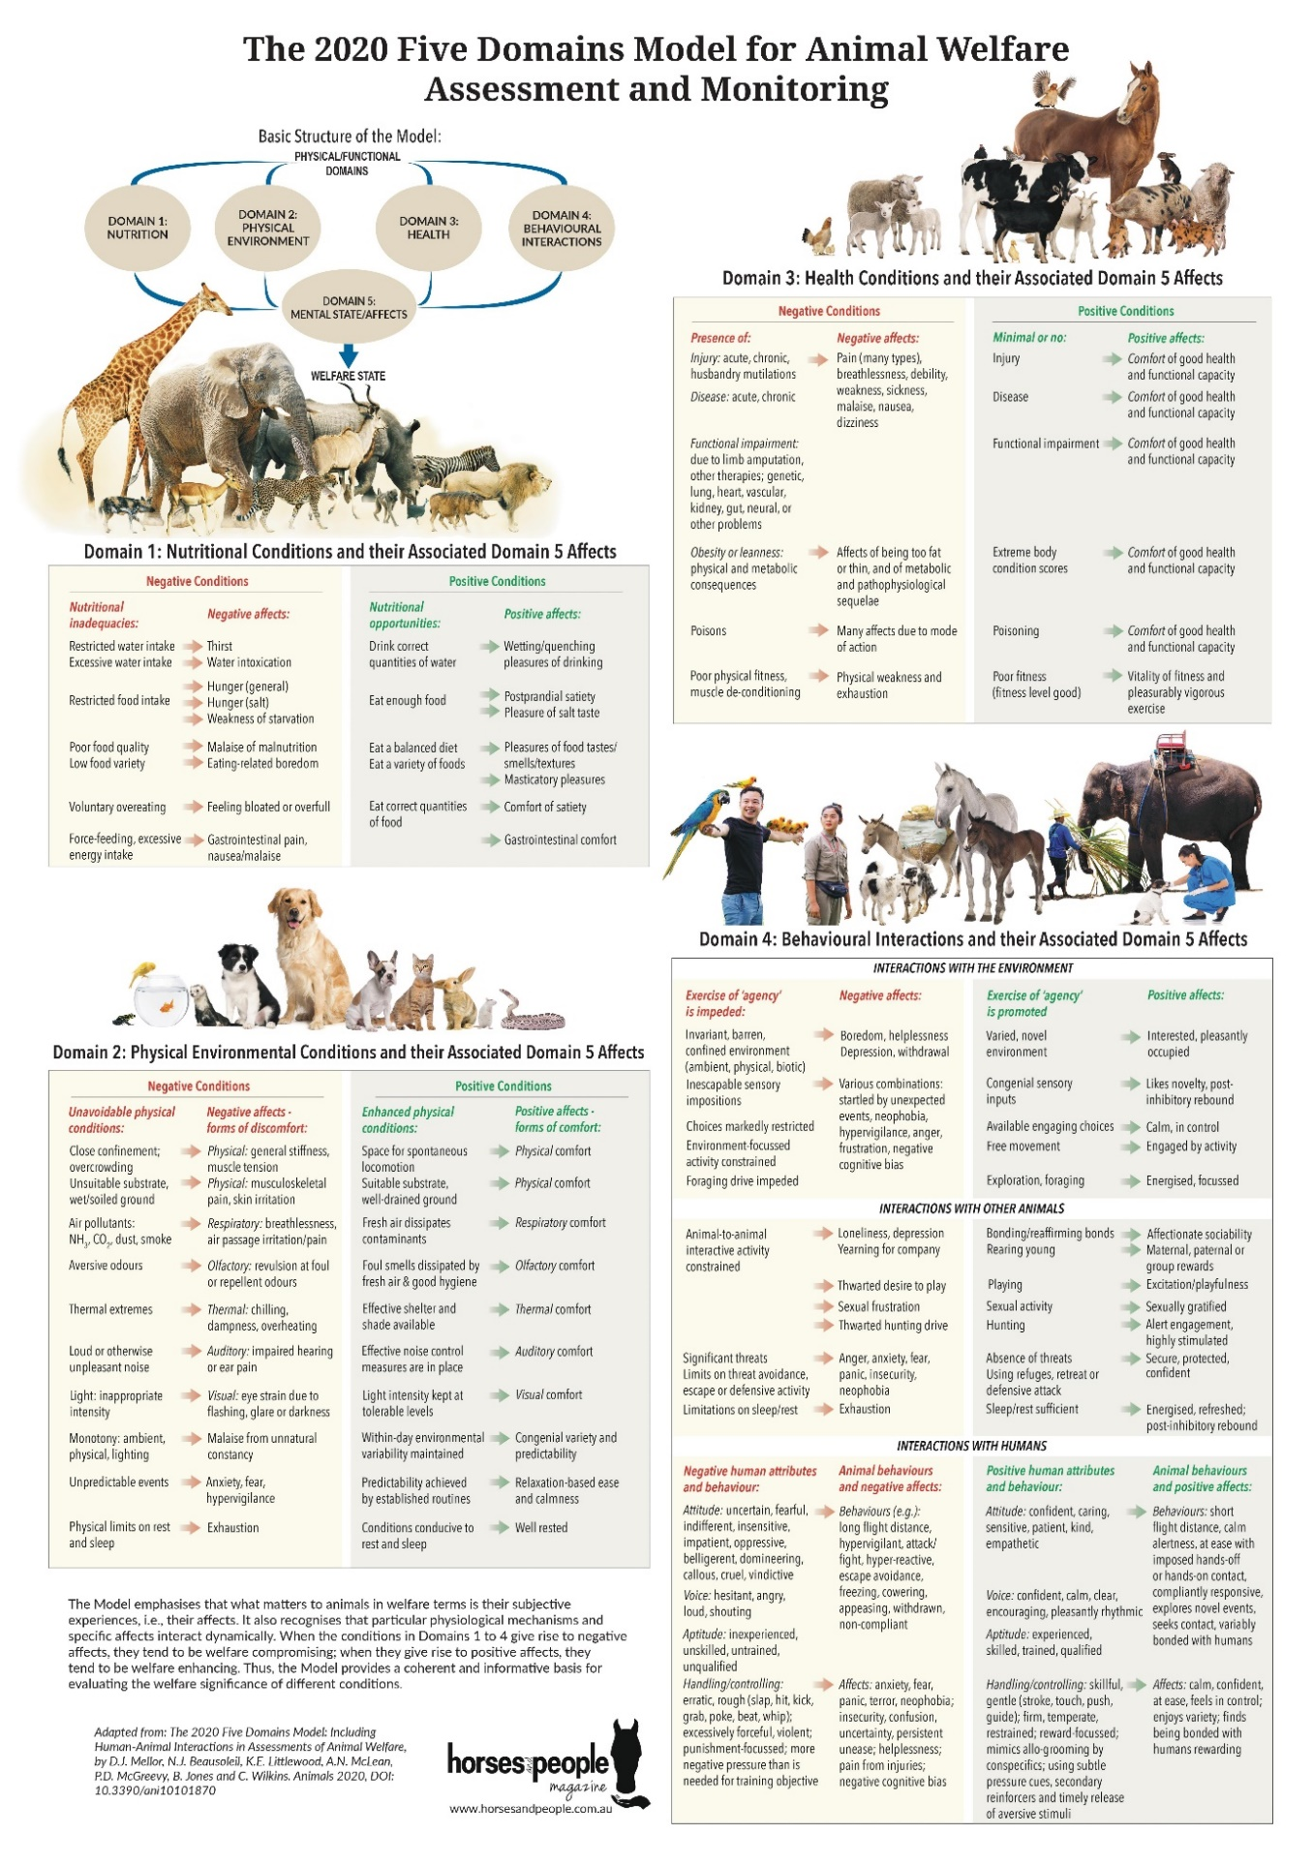

*Figure 1: The Five Domains model by David Mellor (Mellor, Beausoleil, Littlewood et al., 2020)*

**Current Situation in Germany**

According to the 2019 IPSOS study, there are 2,3 million equestrians in Germany which equals 3,3% of the German population. The majority of German equestrians are female and older than 40 years of age and with an above average income (Deutsche Reiterliche Vereinigung e.V. & FN, 2019). The 2019 IPSOS study also shows that only 13-16% of the German equestrians keep their horses at home or in a private barn from a relative or a friend. Therefore, most horses are kept at commercial livery yards. Moreover, by looking at the 2014 structural data collection of horse keeping institutions, it can be said that 77-82% of these livery yards keep the horses in indoor or outdoor single stalls. However, paddock stalls and open stalls are offered to 50% on average (Hölker, Wiegand, Münch et al., 2014).

The average private horse owner spends approximately two to three hours per day at the barn and pays between 480€ and 990€ for one horse per month. The costs per month include barn rent, feed, farrier, vaccination, deworming, dentist, savings for vet bills, horse liability insurance, surgery insurance, equipment, riding lessons, gas and the participation in competitions. The expenses can highly differ depending on the region the horse lives in and in what type of barn the horse is stabled at (Junker, 2020).

The German legislation, §2 of the Tierschutzgesetz (animal protection act), says that whoever keeps or takes care of an animal is responsible for its species-appropriate housing, nutrition and handling and is further prohibited to injure or hurt an animal so that it might cause pain or suffering. That is why the Bundesministerium für Ernährung und Landwirtschaft (national ministry of nutrition and agriculture) developed the 2009 guidelines for the assessment of equine husbandry referring to welfare aspects.

According to the Bundesinformationszentrum Landwirtschaft (National information center for Agriculture) and a blog entry of the Welttierschutzgesellschaft e.V. (World animal welfare society) in 2021, it is still common to keep horses in single stalls and to feed high amounts of concentrates and pellets. However, there is an increasing tendency of horse owners stabling their horses in group housing systems instead of individual stalls. Both of the two mentioned organizations stress the importance of social contact, free locomotion, space and high-fibrous nutrition in order to reach a sufficient welfare status. There are big differences between sport horses and leisure horses and the welfare status also varies between summer and winter time, whereas during the winter time, the welfare status of horses is lower on average (Baumgartner, Kuhnke, Hülsbergen et al., 2021).

Nevertheless, the majority of active equestrians in Germany are expecting more animal welfare and digitality for 2030, which represents the need for putting science about equine welfare into practice. On the other hand, every fifth active equestrian in Germany complains about bad horse husbandry and horse handling (Deutsche Reiterliche Vereinigung e.V. & FN, 2019).

**Welfare Science and Mellor’s Five Domains Model**

How people think about welfare has changed increasingly during the past years. During the 1980s and 1990s, there was a higher focus on negative experiences in animals, whereas today, more importance is given to the mental state and developing positive experiences (Mellor & Burns, 2020). However, welfare is a broad term and evaluating which condition represents welfare is not an easy task. That is why the Five Domains Model is a tool that can be used to get a better understanding of welfare. The Five Domains Model (figure 1) is a “focusing device to facilitate systematic, structured, comprehensive and coherent assessment of animal welfare” which has been developed by David J. Mellor in 1994 originally as the Five Freedoms model (Mellor, 2017). The updated Five Domains (see appendix A) are the following: 1 Nutrition, 2 Physical Environment, 3 Health, 4 Behavioural Interactions (interactions with the environment, with other animal and with humans) and 5 Mental State/Affects which is associated with each of domains 1-4 (Mellor, Beausoleil, Littlewood et al., 2020). The model focuses on the subjective experiences of the horses (see figure 2), meaning what matters to the horses in terms of welfare. The first three domains focus on what features disturb the body’s internal stability (homeostasis) and they focus on the negative survival-critical affects, these features are associated with, to restore the body’s internal stability. In contrast to that, domain 4 (behavioural interactions) focuses on external situation-related affects. Whether or not the situation-related affects are positive or negative mostly depend on the possibility of agency in the horse. Agency can be defined as an animal’s engagement in “voluntary, self-generated and goal-directed behaviours” (Mellor, 2016). For example, a horse wants to play with other horses, but when social contact is limited by management and housing, the horse might feel depressed after repeated constraint. The depression is the negative situation-related affect in this example.

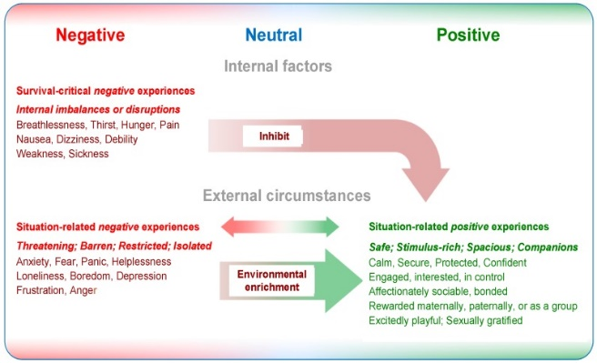

*Figure 2: Illustration of different types of subjective experiences in response to animal welfare (Mellor, 2017)*

In their book “Domestic Animal Behaviour and Welfare” (2015), Donald M. Broom and Andrew F. Fraser stressed the importance of the motivational state of the horse as the factor deciding about the mental state (negative or positive affect) in the horse. A horse’s motivation to look for food is higher when the horse has not eaten for multiple hours compared to a horse that has just eaten. Causal factors that initiate the behaviour to look for food are sensory inputs such as a shift in the blood level or the scent of food.

The original Five Freedoms’ approach was to promote freedom from e.g. hunger, distress, injury, discomfort or freedom to express normal behaviour. However, the term freedom implies that a horse’s life can be completely free of something which is not possible. The Five Freedoms also focused on negative experiences only and left out the positive experiences as well as the mental state of the horse (Mellor, 2016). That is why the Five Domains’ aim is to move beyond opportunities and a minimum standard of care, but towards positive experiences which equate actual welfare (Mellor & Burns, 2020). Even if the Five Domains are not about good or bad welfare, the model can still be used for grading a horse’s living situation in order to seek for enhancement options. For compromise grading, meaning analysing the amount, severity, intensity and duration of negative experiences, a five-tier scale from A to E (A: none, B: low, C: mild to moderate, D: marked to severe, E: very severe) is recommendable. For enhancement grading, meaning measuring the availability of opportunities, the use of opportunities and finally the availability of positive affects, a four-tier scale from 0 to +++ (0: none, +: low-level, ++: mid-level, +++: high-level) can be used (Mellor, 2017). In order to know which grade fits to the given situation, it is advisable to consider scientific literature such as the AWIN Welfare Assessment Protocol for Horses (Minero, Dalla Costa et al., 2015) or the WUR Welfare Monitoring System (Livestock Research, 2012).

**Evidence-based Practice**

Eventhough the Five Domains model has been updated just in 2020, there have already been research articles released that deal with the grading and assessment of equine welfare. In 2020, D.M. Mellor and M. Burns released the paper “Using the Five Domains Model to develop welfare assessment guidelines for Thoroughbred horses in New Zealand”. The authors tried to develop guidelines for Thoroughbred horses which refer to the Five Domains model. However, the guidelines are rather unspecific as the authors wanted to make the guidelines applicable to other non-Thoroughbred equids. The recently released article “Use of Remote Camera Traps to Evaluate Animal-Based Welfare Indicators in Individual Free-Roaming Wild Horses” (Harvey, Morton, Mellor et al., 2021) represents a study in which wild horses in Australia have been observed directly and through camera traps over a period of 15 months to assess these horses using the Five Domains model. Furthermore, the German researchers Dr. Miriam Baumgartner and Dr. Margit Zeitler-Feicht developed, together with the Technische Universität München, a digital consulting and checklist tool called BesTUPferd. With this tool, horse businesses and private horse owners are supposed to be able to evaluate how their horse’s living situation scores on welfare (BesTUPferd, n.d.).

Implementing practice requires not only a shared vision, but also effective leadership and convincing communication, meaning that for a success in implementing a scientific model into practice, it needs channels of communication to spread the knowledge and the importance. The next step would be to provide feedback and increase positive reinforcement. Resistance to change in practice is usually the result of people being feared about something new. With effective communication it might be possible to reduce this fear (Gesme & Wiseman, 2010).

Originally, the term ‘evidence-based practice’ derives from the health system because health insurances were not willing anymore to pay for something that is not scientifically proven to work (Peters & Black, 2012). In their book “Evidence-Based Horsemanship” (2012), the horse trainer Martin Black and the scientist and neuropsychologist Dr. Stephen Peters talk about evidence-based practice related to the handling, husbandry and training of horses. Dr. Stephen Peters still sees a “large information gap between available knowledge and what is practised in the horse world.” (Peters & Black, 2012, page viii). He also stresses the negative mental outcomes of this information gap i.e. “increased physiological stress reactions in confined and isolated horses” (Peters & Black, 2012, page 79) and stereotypic behaviours such as weaving and pacing, as a result of loss of free movement, linked to “high levels of stress and anxiety and a reduction of serotonin” (Peters & Black, 2012, page 80) and therefore a possible depression, cribbing, as a result of lacking social contact and “lack of control over one’s environment” (Peters & Black, 2012, page 84), developing obsessive-compulsive behaviour, etc. According to Dr. Stephen Peters, in some cases, one of the causes for horse owners to keep their horses in a deficient welfare state without knowing is Anthropomorphism. Horse owners might think what is good for them, as humans, is good for their horses i.e. feeding two meals a day instead of considering the fact that horses are continuous grazers.

**Attitudes and change of attitudes**

In the end, evidence-based practice requires a certain change of a horse owner’s attitude towards horse welfare and equine husbandry. First of all, it is necessary to understand how the decision of a horse owner is made. For this purpose, the psychological model of Elaboration-Likelihood can be considered (Gerrig, 2018). The Elaboration-Likelihood-Model defines the process of persuasion and the creation of an attitude respectively. The model differentiates between central (high) and peripheral (low) elaboration. High elaboration would require a horse owner to look for scientific evidence and going through a process of evaluating various thoughts while low elaboration requires low thinking and a decision-making process based on superficial hints such as an advertise on TV, for example.

An attitude change is more solid and persistent if a person’s persuasion depends on elaboration of content, which forces a person to think systematically (central/high elaboration), and does not depend on associations and heuristics, which would only require superficial (peripheral/low elaboration) thinking (Smith, Mackie & Claypool, 2015, pages 256-264). Therefore, it is important to understand what influences systematic processing so that favourable situations can be created. The first influence is a person’s motivation which can be divided into three principles, namely mastery motivation, connectedness motivation and me & mine motivation. In the following, there are a few example questions that horse owners might ask themselves in order to find out whether or not they are motivated enough:

* Mastery motivation (importance of being accurate):

Do I want to make a longlasting and reasonable decision about how to keep my horse? What consequences will my decision have in each scenario?

* Connectedness motivation (importance of relations with others):

Is the relation to/opinion of the boarding facility owner, my friends who have their horses stabled at the same yard, etc. important to me? Is the relation to/opinion of my discussion partner who wants to persuade me (horse trainer, veterinarian, etc.) important to me?

* Me and mine motivation (importance of self-relevance):

In how far does my decision affect myself? Are there enough relevant benefits for me and/or my horse if I switch to a new boarding facility or take welfare improvement measures?

The second influence of a person’s way of processing is the capacity. If a person has the mental resources and the opportunity to concentrate, he/she will be more likely be able to process systematically with high elaboration. A third influence is the emotional state of a person. If there is too much arousal, meaning that a person is in an overly good or bad mood, systematic processing is more difficult compared to when there is little arousal or a neutral mood.

**Attitudes’ influence on behaviour**

After finding out about what influences the way humans process thoughts, the second step is to trigger a certain change in attitude followed by a change in behaviour. The Cognitive Dissonance Theory describes the conflict of making a decision and then finding out about contradictory opinions against that decision afterwards (Gerrig, 2018). An example would be a horse owner who stables a horse in an individual stall with a pasture access of three hours daily and then hears from the riding instructor that this is not beneficial and species appropriate for the horse (dissonance). The bigger the cognitive inconsistency is, the more likely it is that the horse owner will change his/her opinion about keeping horses. However, other than a change in attitude, there are several other ways to reduce or even eliminate the dissonance (Smith, Mackie & Claypool, 2015, pages 275-292).

This applies to e.g. a horse owner who is already aware of the realistic welfare state of the own horse and has an attitude-discrepant behaviour.

By coming up with alternative thoughts, justifications or sometimes even excuses, a person can trick his/her mind to forget about reality, which are negative consequences, personal responsibility, physical arousal, etc. Figure 3 illustrates a possible example of an attitude-discrepant behaviour in a private horse owner and the possible outcomes.

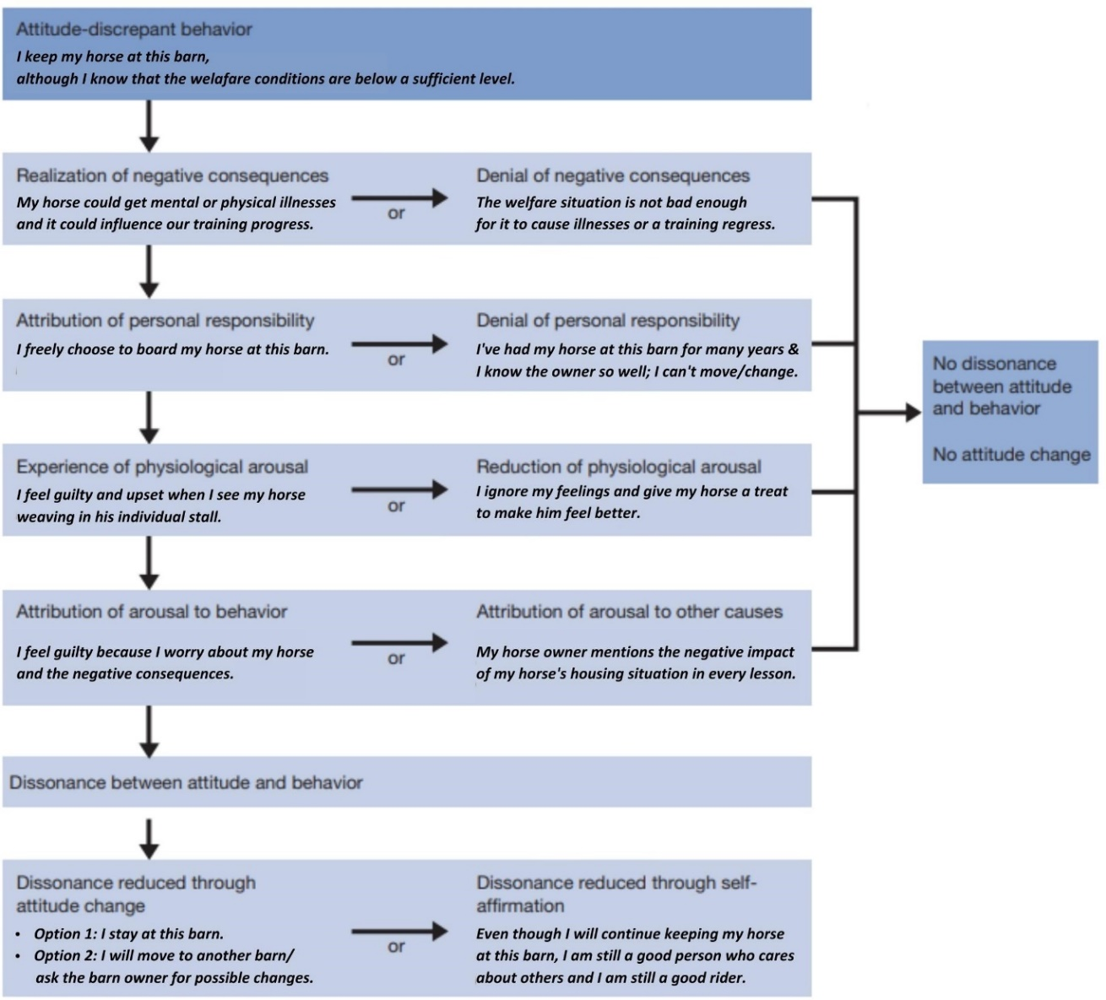

*Figure 3: Reduction of dissonance in an attitude-discrepant behaviour of a private horse owner as an example (Smith, Mackie & Claypool, 2015, page 292, fig. 8.4 -adapted by me)*

In conclusion, an attitude change is necessary for a change in behaviour. Because a change in behaviour should be persistent and thought through, the approach of evidence-based practices requires systematic processing which should be supported by creating favourable situations for persuasive communications.

However, the conservatism principle of social psychology says: “Established views are slow to change” and the accessibility principle says: “Accessible information has the most impact” (Smith, Mackie & Claypool, 2015, page 18). This and the influence of culture, social norms and also possible peer pressure need to be kept in mind when trying to convince a horse owner of considering scientific evidence to evaluate whether or not a certain horse is in an appropriate welfare state. Because of these principles and the fact that dissonance is an uncomfortable feeling that people want to get rid of, a persuasion can lead to resistance of attitude change.

# References

1. Baumgartner, M.; Kuhnke, S.; Hülsbergen, K.-J.; Erhard, M.H.; Zeitler-Feicht, M.H. (2021) *Improving Horse Welfare and Environmental Sustainability in Horse Husbandry: Linkage between Turnout and Nitrogen Surplus.* Sustainability 2021, 13, 8991. [Online] Available at: <https://doi.org/10.3390/su13168991>
2. BestTUPferd (n.d.) *Über BestTUPferd*. Technische Universität München. [Online] Available at: <https://www.besttupferd.de/m/seite/513615/%C3%BCber-besttupferd.html>
3. Broom, D.M.; Fraser, A.F. (2015). *Domestic Animal Behaviour and Welfare.* 5th Edition. Chapter 6 – Welfare Assessment. ISBN 978-1-78064-539-1.
4. Bundesinformationszentrum Landwirtschaft (n.d.) *Tierwohl in der Pferdehaltung.* [Online] Available at: <https://www.praxis-agrar.de/tier/pferde/tierwohl-in-der-pferdehaltung>
5. Bundesministerium für Ernährung und Landwirtschaft (2009) *Leitlinien zur Beurteilung von Pferdehaltungen unter Tierschutzgesichtspunkten.* [Online] Available at: <https://www.bmel.de/SharedDocs/Downloads/DE/_Tiere/Tierschutz/Gutachten-Leitlinien/HaltungPferde.pdf?__blob=publicationFile&v=3>
6. Deutsche Reiterliche Vereinigung e.V.; FN (2019) *Pferdesport in Deutschland.* 2019 IPSOS Studie. [Online ] Available at: <https://pferde.landwirtschaft-bw.de/pb/site/pbs-bw-mlr/get/documents_E1391157523/MLR.LEL/PB5Documents/hul/Kompetenzzentrum%20Pferd/Fachinformationen%20Neu/Pferdesport/%282020%29%20Ergebnisbericht%20zur%20Ipsos-Studie%202019.pdf>
7. Gerrig, R. J. (2018) *Psychologie.* Chapter 15.3: Sozialpsychologie -Einstellungen, Einstellungsänderungen und Handlungen. 21st edition. Pearson Germany. ISBN: 978-3-86894-323-8.
8. Gesme, D.; Wiseman, M. (2010) *How to Implement Change in Practice.* Journal of oncology practice, 6(5), 257–259. [Online] Available at: <https://doi.org/10.1200/JOP.000089>
9. Hölker, S.; Wiegand, K.; Münch, C.; Spiller, A. (2014) *Pferdehaltung Heute – Eine Strukturdatenerfassung pferdehaltender Betriebe in Deutschland.* Georg-August Universität Göttingen. [Online] Available at: <https://www.uni-goettingen.de/de/document/download/430d074d1886b8e9e7210cfee0c7fd9c.pdf/Brosch%C3%BCre%20Strukturdaten%20-%20Final.pdf>
10. Junker, Lena (2020) *Was kostet ein Pferd im Monat? Die Kosten der Pferdehaltung im Überblick.* Blog Haltung. Fundis Reitsport. [Online] Available at: <https://www.fundis-reitsport.de/blog/haltung/kosten-pferd/#monatliche-kosten-f-r-ein-pferd-in-der-bersicht>
11. Livestock Research (2012) Wageningen University & Research Centre. Welfare Monitoring System – Welfare Assessment Protocol for Horses [Online] Available at: <http://library.wur.nl/WebQuery/wurpubs/429967>
12. Mellor, D.J. (2017) *Operational Details of the Five Domains Model and Its Key Applications to the Assessment and Management of Animal Welfare.* Animals 2017, 7(8), 60. [Online] Available at: <https://doi.org/10.3390/ani7080060>
13. Mellor, D.J. (2016) *Updating Animal Welfare Thinking: Moving beyond the “Five Freedoms” towards “A Life Worth Living”.* Animals (Basel). 2016; 6(3):21. [Online] Available at: <https://dx.doi.org/10.3390%2Fani6030021>
14. Mellor, D.J.; Harvey, A.M.; Morton, J.M.; Russell, V.; Chapple, R.S.; Ramp, D. (2021) *Use of Remote Camera Traps to Evaluate Animal-Based Welfare Indicators in Individual Free-Roaming Wild Horses. Animals* 2021, *11*(7), 2101. [Online] Available at: <https://doi.org/10.3390/ani11072101>
15. Mellor, D.J.; Burns, M. (2020) *Using the Five Domains Model to develop welfare assessment guidelines for Thoroughbred horses in New Zealand.* New Zealand Veterinary Journal, 68:3, 150-156. [Online] Available at: <https://doi.org/10.1080/00480169.2020.1715900>
16. Mellor, D.J.; Beausoleil, N.J.; Littlewood, K.E.; McLean, A.N.; McGreevy, P.D.; Jones, B.; Wilkins, C. (2020). *The 2020 Five Domains Model: Including Human–Animal Interactions in Assessments of Animal Welfare*. Animals 10(10), 1870. [Online] Available at: <https://doi.org/10.3390/ani10101870>
17. Minero, M.; Dalla Costa, E.; Dai, F.; Scholz, P.; Lebelt, D. (2015) AWIN Welfare Assessment Protocol for Horses. [Online] Available at: <https://air.unimi.it/retrieve/handle/2434/269097/384836/AWINProtocolHorses.pdf>
18. Peters, S.; Black, M. (2012) *Evidence-Based Horsemanship.* Wasteland Press, Shelbyville, KY USA. ISBN: 978-1-60047-685-3.
19. Smith, E.R.; Mackie, D.M.; Claypool, H.M. (2015) *Social Psychology.* Fourth Edition. Pages 256-292. Published by Psychology Press (Taylor & Francis). ISBN: 978–0–203–83369–8 (ebook). Welttierschutzgesellschaft e.V. (2021) *Wie geht es den Pferden in Deutschland?* Tierschutzblog. [Online] Available at: <https://welttierschutz.org/wie-geht-es-den-pferden-in-deutschland/>